[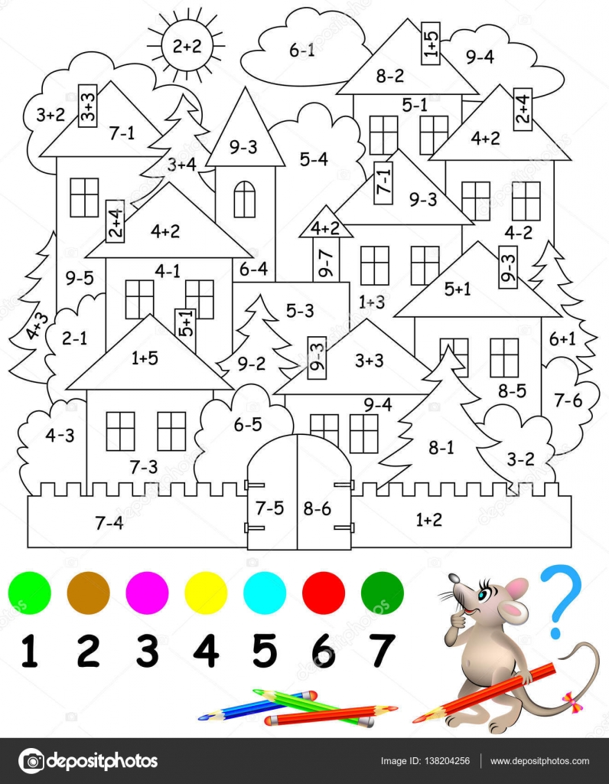](https://st3.depositphotos.com/6872540/13820/v/1600/depositphotos_138204256-stock-illustration-educational-page-with-exercises-for.jpg)